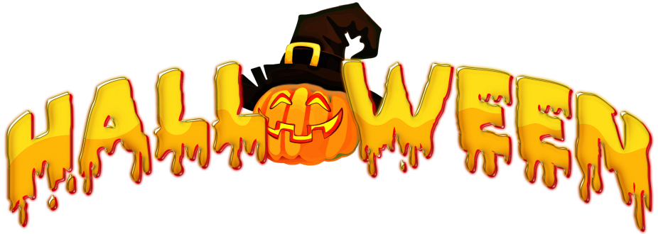
St. Mary Academy
Halloween Costume Contest
St. Mary Academy will be conducting the annual in-school Halloween Costume Contest. Voting will take place in homeroom and one winner from each grade level will move forward in the competition. The faculty and staff will then vote on three winners who will be announced by the days end. The categories are:
- PreK-1
- 2nd-4th
- 5th-8th
- Faculty
Students may wear costumes to school on Friday, October 29, 2021. However, costumes must be in good taste and age appropriate. Please follow these guidelines:
- Parents are advised to preview costumes prior to coming to school.
- Costumes must be appropriate in nature and content.
- No weapons are allowed, i.e. swords, knives, axes, etc.
- Costumes may not restrict movement or compromise the safety of the children (no blow up costumes, please!)
- Face masks must be worn at all times (COVID protocol).
- Costume Masks do not replace face masks and may not be worn during the school day or in class. At no time should children wear both masks.
- Nothing too goory or scary.
- Have fun!
If a costume is deemed inappropriate by school officials, students will be asked to change or sent home.

